### Homework 6_2

#### Problem 1:

% Define the coordinates of the points

x = [0, 6, 8];

y = [0, -18, 0];

% Calculate the differences between adjacent points

dx = diff(x);

dy = diff(y);

% Calculate the derivative using finite differences

derivative = dy ./ dx;

% Create a line plot for the original line

figure;

plot(x, y, 'b', 'LineWidth', 2); % Original line

hold on;

% Create a line plot for the derivative

plot(x(1:end-1), derivative, 'r', 'LineWidth', 2); % Derivative line

grid on;

xlabel('X');

ylabel('Derivative');

title('Graph of the Derivative');

legend('Original Line', 'Derivative', 'Location', 'southwest');

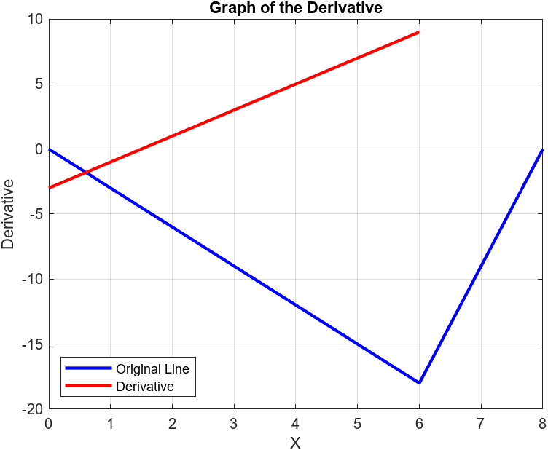

#### Problem 2:

% Define the coordinates of the points

x = [0, 4, 8, 10, 12, 14, 18, 22];

y = [0, 20, 20, 0, 0, -20, -20, 0];

% Calculate the differences between adjacent points

dx = diff(x);

dy = diff(y);

% Calculate the derivative using finite differences

derivative = dy ./ dx;

% Create a line plot for the original line

figure;

plot(x, y, 'b', 'LineWidth', 2); % Original line

hold on;

% Create a line plot for the derivative

plot(x(1:end-1), derivative, 'r', 'LineWidth', 2); % Derivative line

grid on;

xlabel('X');

ylabel('Derivative');

title('Graph of the Derivative');

legend('Original Line', 'Derivative', 'Location', 'southwest');

% Set x-axis and y-axis limits

xlim([0, 25]);

ylim([-30, 30]);

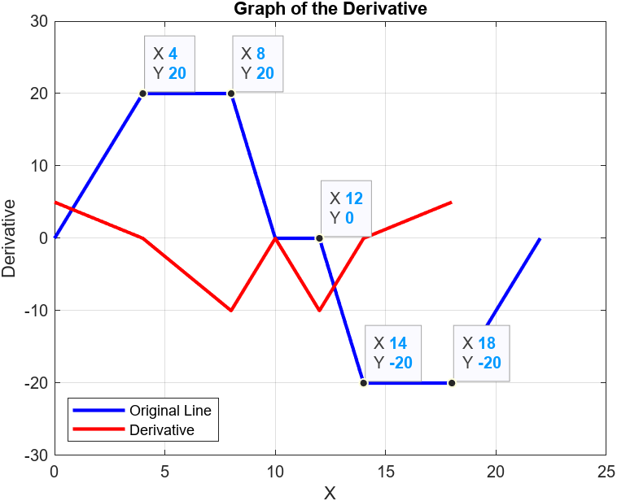

#### Problem 3:

% Define the function

f = @(x) sqrt(x);

% Define the derivative function

df = @(x) 0.5 * x.^(-0.5); % Derivative of sqrt(x) is 0.5 * x^(-0.5)

% Define the range of x values

x_values = -5:0.01:5;

y_values = f(x_values);

derivative_values = df(x_values);

% Plot the original function and its derivative using fplot

figure;

fplot(f, [min(x_values), max(x_values)], 'b', 'LineWidth', 2);

hold on;

fplot(df, [min(x_values), max(x_values)], 'r', 'LineWidth', 2);

xlabel('x');

ylabel('y');

title('Function and its Derivative');

legend('y = sqrt(x)', 'Derivative', 'Location', 'northeast');

grid on;

hold off;

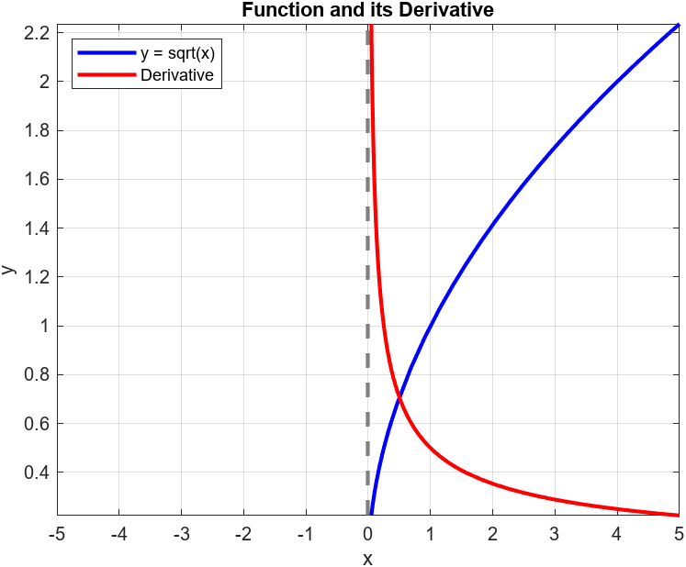

#### Problem 4:

% Define the time range

t = 0:0.1:10;

% Calculate displacement y

y = -10*t + 100*(1 - exp(-2*t));

% Calculate velocity dy/dt

velocity = -10 + 200*exp(-2*t);

% Calculate acceleration d^2y/dt^2

acceleration = -400*exp(-2*t);

% Create a figure

figure;

% Plot displacement, velocity, and acceleration on a single graph

subplot(1,1,1);

plot(t, y, 'b', t, velocity, 'r', t, acceleration, 'g', 'LineWidth', 2);

xlabel('Time (t)');

ylabel('Value');

title('Displacement, Velocity, and Acceleration vs. Time');

legend('Displacement', 'Velocity', 'Acceleration');

grid on;

